**Assignment Information and Goal**  
In this class assignment you will demonstrate a detailed knowledge of WordPress intermediate skills by adding plugins to extend WordPress.

**Read All Project Documents before Starting the Work**Please read this document completely before starting the project work.   
Please also read the template so that you understand what information, content, and screens you are required to capture and insert into the template file.

**Documents for This Assignment**  
this is the assignment instructions document.   
It contains the information on the necessary tasks to be completed for the assignment.  
The other documents associated with this assignment are the assignment template, the website content, and the rubric.   
Please do not alter template formatting or delete parts of this assignments template.

**Website Content document**  
there is no Website Content document for this assignment. All the content is contained within MySQL database tables.   
  
**Template File**  
please download, rename, complete and then submit the assignment template document to receive a grade for this assignment. Please provide partial screen captures where requested.  
The rubric provides detailed information on how the assignment is graded.

If you have questions about the assignment, content layout, or formatting; please contact the class instructor ASAP. Please use the IRT form to request assistance.  
  
**Assignment 04 Parts Index:**Part A - Student Information  
Part B - Website Information  
Part C – WordPress Website Extensions  
Part D - Selecting Forms using Best Practices  
PART E - Exercise Best Practices to Add Widgets  
PART F - PHP **(Work done on the Template)**

PART G - Assignment Wrap-up

**Assignment 04 Actions:**Part A - Student Information

1. Download and save a copy of the Assignment 04 template document.
2. Rename the template document **[Your-Full-Name]-**Assignment 04 Template.docx.
3. Go to the assignment template and complete Part A.

Part B - Website Information

1. Create a WordPress site on either a shared web host, a Pantheon, or a cloud account.

For the shared web host users, please create it as an “**In Directory**” WordPress site with the following attributes:  
**Protocol:** http://  
**Domain:** Select default domain

**In Directory:** “***mod4assignment4***”

**Database Name:** Use your web hosts default database name (remember to record it)

**Site Name:** “Assignment 4 WP”

**Site Description:** “IT320 Assignment 04 Shared”

-OR-  
For **Pantheon (PaaS)** users create a WordPress site with following attributes

**Site Title:** “Assignment 4 WP Pantheon”

-OR-

For **Cloud users, create a** WordPress site record the following attributes

Connection/Container: [your-initials]wpca04

Website Site Title: “Assignment 4 WP CA”

1. Go to the template and record website creation settings in the assignment template at Part B -1-, -2-, or -3- depending on which type of host environment you used.

Part C – WordPress Website Extensions + Comments

1. Check for WordPress version updates. If your WordPress build did not create the most recent version of WordPress, update it now.
2. Check for Plugin updates. If your plugins need updating, please do so now.
3. Check for Theme updates. If your themes need updating, please do so now.
4. Add a new Theme named “Simpel” and make it the active theme  
   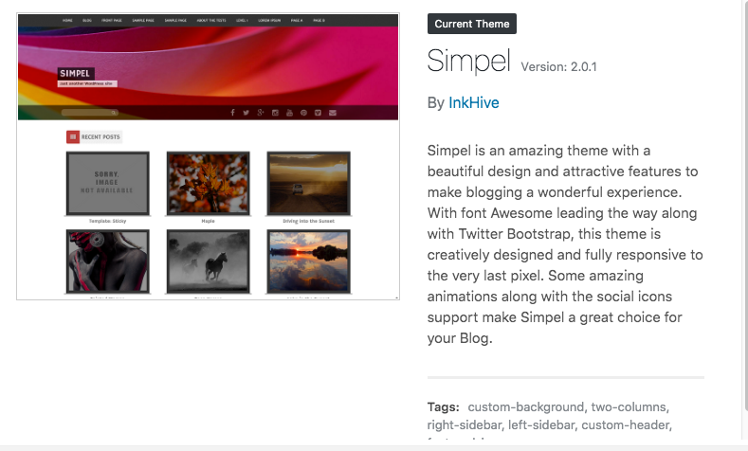
5. Make sure that the Classic editor plugin is not installed on your WordPress site.
   1. IF it is active, deactivate it and delete it.
6. Create a new menu and configure it to automatically add pages to it and to display on the website as the main menu.
7. Enable comments display on the Pages and Posts Admin list pages
8. Add all asset image files to the WordPress site.
9. Create a new Page named “Biography” with the following attributes:
   1. First block paragraph of IPSUM (Latin) text
   2. Add 1 image block to the Biography page, above and below the first paragraph text block
   3. Add a second text paragraph block (IPSUMtext) below the image
   4. Add a second image block (use a different image) to the Biography page, above and below the second paragraph text block
   5. Verify that comments are enabled for this Page
10. Create a new Page named “About us” with the following attributes:
    1. First block paragraph of IPSUM (Latin) text
    2. Add 1 image block to the About us page, above and below the first paragraph text block
    3. Add a second text paragraph block (IPSUMtext) below the image
    4. Add a second image block (use a different image) to the About us page, above and below the second paragraph text block
    5. Verify that comments are enabled for this Page
11. Add a Post > Category named Birds
12. Add Post > Tags: Duck, Bluebird, and Hawk
13. Create a new Post “Bird Post 1 ” with following attributes
    1. 1 paragraph of IPSUM (Latin) text
    2. 2 images with Alt-Text that describes each image, and ends with a period followed by a space.
    3. Add Category of Birds
    4. Add Tags based on the images you selected, one tag for each type of bird image
    5. Verify that comments are enabled for this Post
14. Create a second Post “Bird Post 2 ” with following attributes
    1. 1 paragraph of IPSUM (Latin) text
    2. 2 images with Alt-Text that describes each image, and ends with a period followed by a space.
    3. Add Category of Birds
    4. Add Tags based on the images you selected, one tag for each type of bird image
    5. Verify that comments are enabled for this Post
15. Configure settings on comments so that email and name are not required to leave comments.
16. Open an incognito web browser and add 1 comment to the two Pages and two Posts.
17. As a site admin approve all comments.
18. Go to the **assignment template** and record the requested screen captures and answers in the template at Part C.

Part D - Selecting Forms using Best Practices

1. **Using the best practices we covered in the previous classes to find, evaluate, select and Install a Form plugin** that meets the following feature requirements:
   1. Form is no cost
   2. Form does not have a premium or pro version
   3. Form plugin supports ability to create multiple forms (new forms)
   4. Form supports adding fields
   5. Supports required and optional field settings
   6. Form fields supported include text, telephone number, email, URL, number and date
   7. Form has built in anti-spam using honeypot fields or supports additional extensions (plugins) that add honeypot functionality to the form plugin
   8. Form supports the option to redirect to any page you choose after mail sent successfully or there is an additional plugin that adds this functionality to the form plugin
   9. Form supports, or there is an additional plugin that extends the form plugin so that it supports the saving of contact form submissions data to the WordPress site’s database.
   10. Form supports, or there is an additional plugin that extends the form plugin so that it supports exporting form data to a CSV file.
   11. Form plugin(s) are compatible with our WordPress site
   12. Form plugin(s) are well maintained
   13. Form plugin(s) have a decent number of active installations
   14. Form plugin(s) have good reviews
2. **Use best practices to create a list of possible; candidate form plugins** 
   1. **Hint – you may be looking sat one Form plugin in particular that you have previous experience with, and all you need to do is find additional plugins that extend its functionality.**
   2. **Keep track of the plugin names you find, those you are considering for evaluation, and your feature comparison results.**
3. **Once you have selected a form plugin that meets or exceeds your feature requirements, install, activate and implement the plugin(s).**
4. **Using the form plugins, create a new form named “Contact Us” with the following fields and attributes:**
   1. Name – text (required)
   2. Email – email (required)
   3. Subject - text
   4. Message – text area
   5. Honeypot field 1
   6. Honeypot field 1
5. **Using the form plugins, create a new form named “Order Fruitcake” with the following fields and attributes:**
   1. Name – text (required)
   2. Address – text (required)
   3. City – text (required)
   4. State– text (required)
   5. Zip – text (required)
   6. Phone – Telephone
   7. Fax - telephone
   8. Email –email (required)
   9. Number of Fruitcakes: <number 1-10> (required)
   10. Honeypot field 1
   11. Honeypot field 1

1. Create a WordPress pages named “Contact Us” on the site, add the new “Contact Us” form to it.
   1. Remember to check that they show up on you Client Facing WP site with menu options for each of the forms.
2. Create a WordPress pages named “Order Fruitcake” on the site, add the new “Order Fruitcake” form to it.
   1. Remember to check that they show up on you Client Facing WP site with menu options for each of the forms.
3. Go to the **assignment template** and record the requested screen captures and answers in the template at Part D.

PART E - Exercise Best Practices to Add Widgets

1. **Using WordPress plugins best practices (that we covered in class),** find and add **4** widget plugins to your Assignment 04 WordPress site.  
   Most native widgets were covered in class.  
   I suggest you find new non-native WordPress Plugin Widgets using best practices.  
   Try not to use the Plugin Widgets we covered in the activity or class.  
   Use WordPress best practices when selecting your plugin widget.   
   A good place to start is a Google search for WordPress widget plugins.
2. If your widget plugin requires an image, you may use the images provided in the assignment assets folder
3. Go to the assignment template and record the requested screen captures and answers in the template at Part E.

PART F - PHP

PHP Questions are in the template.

1. Go to the assignment template and record the requested screen captures for Part F.

PART G - Assignment Wrap-up  
Go to the template and record the requested answers at Part G.

**Congratulations. You have completed this assignment.**

Submit your completed Assignment 04 Template to D2L.